

PROFESSIONAL PARTNER

☐ YES! Sign us up as a PROFESSIONAL PARTNER with the Ontario Land Trust Alliance. Our contribution of $750 is enclosed (see footnote below).

☐ NO, thank you. We do not wish to become a Professional Partner at this time, but please accept our charitable donation of $

Please complete and print this form, and send to OLTA by email to admin@olta.ca or by mail:

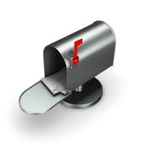
Ontario Land Trust Alliance Inc.
P.O. Box 54 Acton
Acton, ON L7J 2M2

Company Name:
Address:
City: Province:
Postal Code:

Phone: E-mail: Website:
Contact Name and Title:

For Professional Partners, please provide description of your company and/or services, including region served (max 100 words please)

For charitable contributions, please indicate name(s) for acknowledgement

☐ As noted above ☐ As noted here:
☐ I (we) wish to remain anonymous, thank you.

METHOD OF PAYMENT

☐ Cheque ☐ VISA ☐ Mastercard

Card # Expiry Date:

Signature:

* If you prefer to provide your credit card information by phone, please call our Member Services Coordinator at 416-588-6582 and provide your card information directly.

Thank you for your commitment to advancing Ontario's land trust movement!

