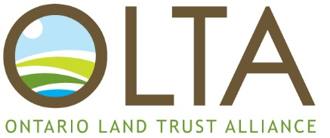

**2023 Ontario Land Trust Alliance Awards**

**Nomination Form – Deadline is 5:00pm September 30th**

Award Category: See Awards Overview for details.

Angus McLeod Vision Award

OLTA Vision Award

OLTA Emerging Land Trust Leader Award

OLTA Land Trust Award for Excellence

Nominee Information:

Name:

Title/Profession/Role:

Organization/Company:

Phone: Email:

Nominator Information:

Name:

Title/Profession/Role:

Organization/Company:

Phone: Email:

Nomination: Please provide examples of your nominee’s contributions to support your nomination.

[Suggested word count: 500]