

**PROFESSIONAL PARTNER**

☐ **YES! Sign us up as a PROFESSIONAL PARTNER with the Ontario Land Trust Alliance. Our contribution of $750 is enclosed** (*see footnote below*).

☐ **NO, thank you**. We do not wish to become a Professional Partner at this time, but please accept our charitable donation of $

***Please complete and print this form, and send to OLTA by email to*** ***admin@olta.ca*** ***or by mail:***

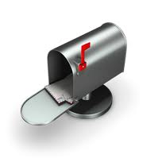Ontario Land Trust Alliance Inc.

P.O. Box 54 Acton

Acton, ON L7J 2M2

Company Name:

Address:

City:       Province:

Postal Code:

Phone:       E-mail:       Website:

Contact Name and Title:

***For Professional Partners, please provide description of your company and/or services, including region served*** *(max 100 words please)*

***For charitable contributions, please indicate name(s) for acknowledgement***

☐ As noted above ☐ As noted here:

☐ I (we) wish to remain anonymous, thank you.

**METHOD OF PAYMENT**

☐ Cheque ☐ VISA ☐ Mastercard

Card #       Expiry Date:

Signature:

*\* If you prefer to provide your credit card information by phone, please call our Member Services Coordinator at 416-588-6582 and provide your card information directly.*

**Thank you for your commitment to advancing Ontario's land trust movement!**